Simulation 1. TD Confounded events before C and interim C-E.
The cause C01 occurred at hour 18, and E occurred at hour 22. Different datasets were used for confounds at different hours.
For the left panel (strength of the cause), when there was no confound, the strength for C is the same as if the confound occurs before C (hours 15, 16, 17). If the confound occurred interim C-E (hours 19, 20, 21), then the causal strength for C is higher. There is no difference in the strength of C depending on when the confounds occurs during the interim period.
For the right panel (strength of the confound), the strength is higher if the duration to E is short (hour 21) than long (hr 15).
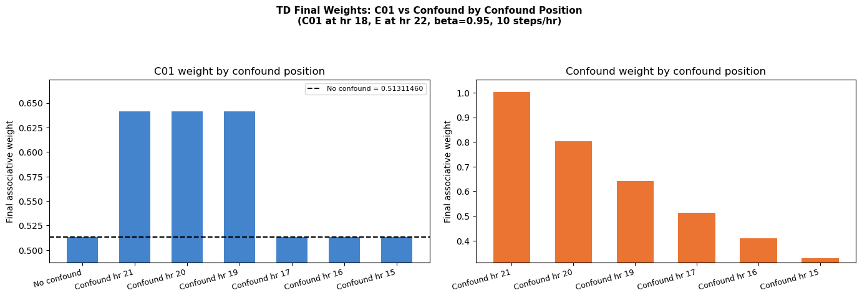

Simulation 2. A Single Uncorrelated Lure, 24 Trials
For the Bayesian model, though all three conditions are very close together, can see that C is learned slightly better for No Lure, then for Lure Uncorrelated Before C, then for Lure Uncorrelated Between C and E. For TD, difference is almost imperceptible, in graph, though technically the final strength for C is the slightest bit higher for the Lure Uncorrelated Between C and E condition because of the second order conditioning effect.
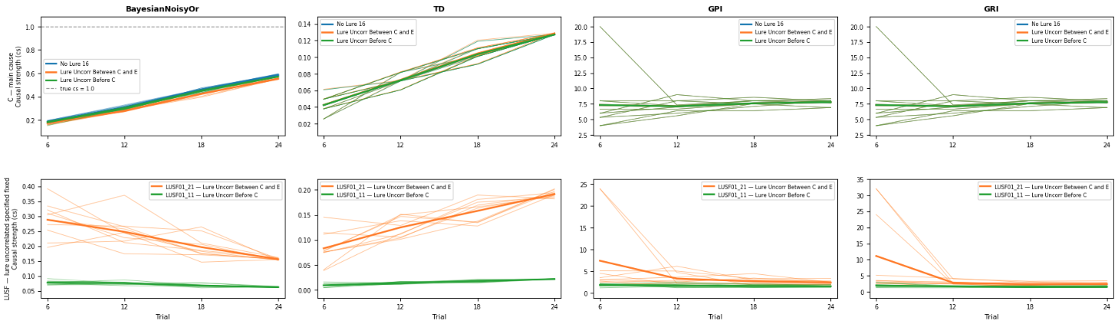

Sim 3. Adding 20 Uncorrelated Lures 24 Trials
With lots of uncorrelated lures and only a few trials, some will be highly correlated with the effect so will compete to explain E. For TD, C is learned the same in the No Lure and the Lure Uncorrelated Before C conditions, as always. C is learned best in the Lure Uncorrelated Between C and E condition because of the second order learning effect.
For the Bayesian model, C is learned fastest in the No Lure condition, then in the Lure Uncorr Before C condition, and then in the Lure Uncorr Between C and E. Between C and E condition provides the most competition with C because of the shorter delay. The comparison between Lure uncorrelated between C and E vs. Lure Uncorr Before C simply changes when the lures occur. The former ones have a shorter delay than the longer ones. So the difference is not about whether they occur before vs. interim, this is just a proxy way in the simulation to create 20 lures with shorter delays vs. 20 lures with longer delays.
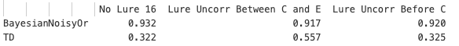
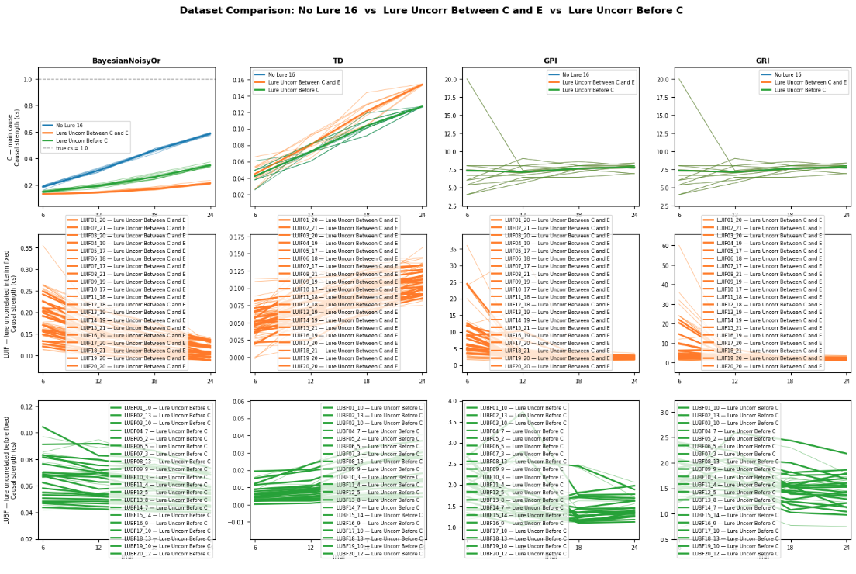

Simulation 4. Adding 1000 timesteps per hour for TD
TD basically learns nothing.
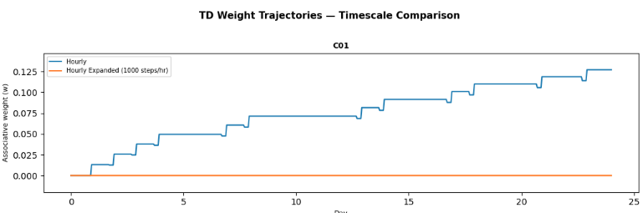

Simulation 5. TD Modifying β (Beta) – the trace decay/persistence rate
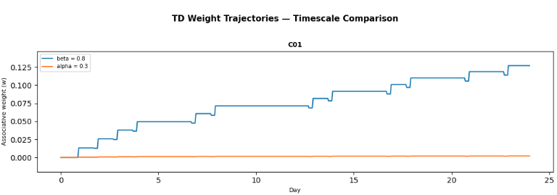

Simulation 6. TD Modifying Ɣ (Gamma)
Final w_C01 (gamma = 1.0) : 0.3283
Final w_C01 (gamma = 0.5) : 0.3277

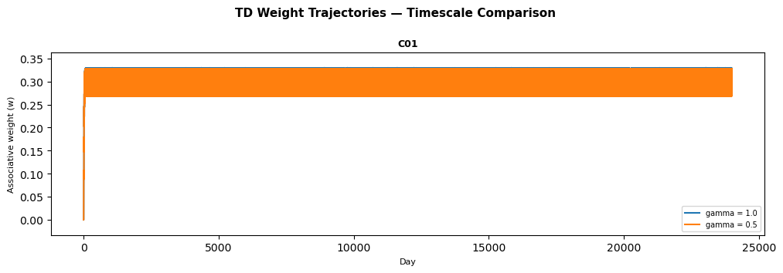

Simulation 7. Informativeness – Changing the strength of C
When causal strength is lowered from 1 to .5, Predictive Informativeness (GPI) gets weaker, but retrospective does not (GRI)
GPI GRI
cs = 1.0 8.000 8.0
cs = 0.5 1.626 8.0

Simulation 8. Informativeness – Changing the number of other causes of E When a second causes is added, retrospective informativeness (GRI) falls considerably more than prospective (GPI).
GPI GRI
2 causes 5.412 2.667
1 cause 8.000 8.000

Simulation 9. Short vs. Long Delay
1 vs. 21 hr Delay with 24 trials, 1 cause. In the 21 hr delay condition, the causal strength for the long datasets is very low for all models and shows barely any learning
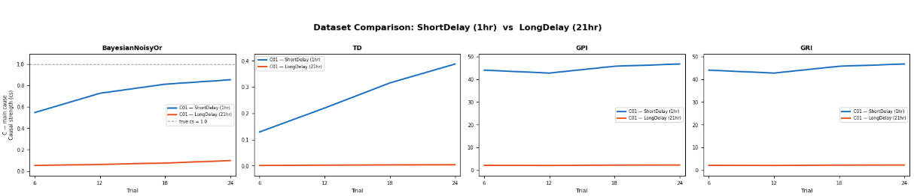

Simulation 10. Long delay can be learned with enough data.
21 Hr Delay but with 240 Trials, 1 cause
- After 240 trials, Bayesian NoisyOr does learn and gets to about .8
- TD never gets very high maxing out at about .011. Perhaps that makes sense because the value represents the discounted prediction.
- GPI and GRI stay about flat - these don't exhibit learning curves in general.
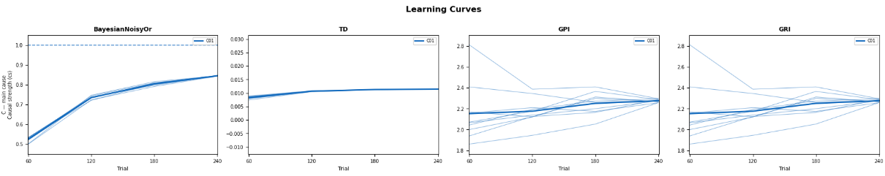

Simulation 11. Bayesian Model Confounds at different times
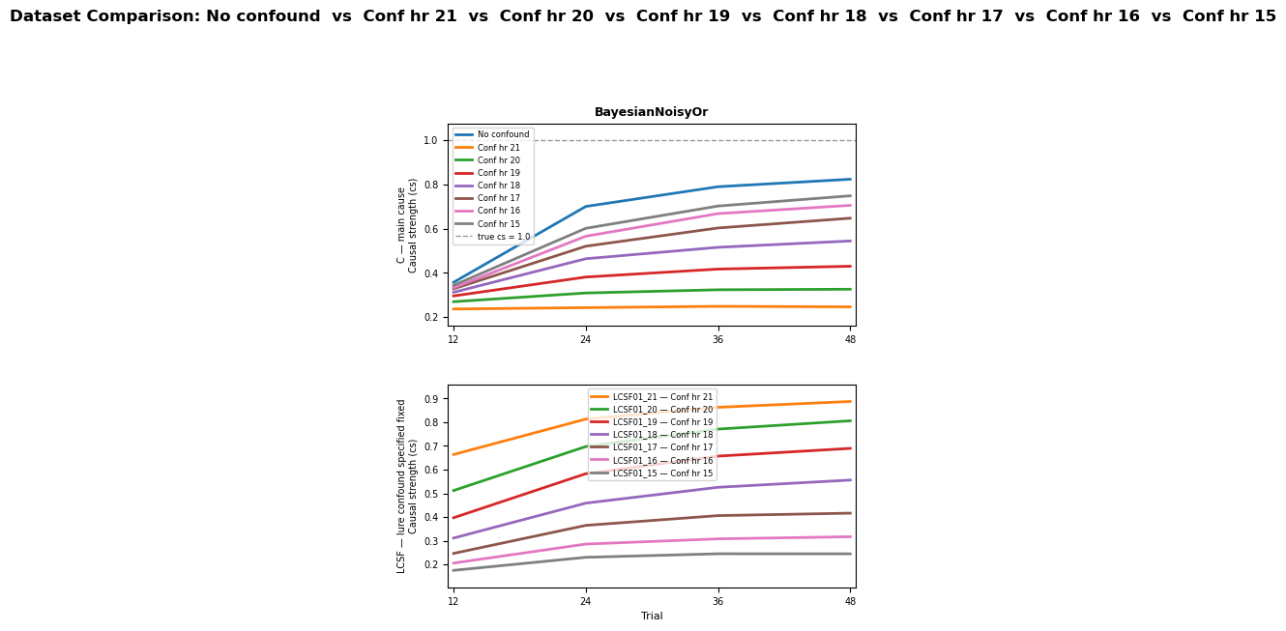

Simulation 12. Adding 20 Uncorrelated Lures at different times with 192 trials
Compare to Simulation 3. With enough trials eventually the Bayesian model overcomes having many lures and converges on a similar strength for C if there was no lures. TD continues to show a big disparity between lures that occur before C vs. during the interim period. This is the 2nd order conditioning phenomenon playing out even more dramatically over time.
